


User Guide
Updated: 1/24/13

Table of Contents
About EBSCO eBooks 3
System Requirements 3
Inside this User Guide 3
Installing Adobe Digital Editions 3
Searching for eBooks 4
eBook Detailed Record 7
eBook Viewer 8
Using the eBook Viewer Toolbar 9
Downloading an eBook 10
Placing a Hold on an eBook 12
eBooks and the My EBSCOhost Folder 13
Creating Notes on eBooks 14
Dictionary 16

About EBSCO eBooks
With EBSCO’s extensive collection of eBook titles on EBSCOhost, users can search within a wide range of relevant eBooks using the powerful EBSCOhost search experience. With every search, relevant eBook titles will appear directly alongside databases and other digital content, exposing users to the full depth of the library’s offerings. With hundreds of thousands of titles available across all major subject areas, libraries can build collections of frontlist titles from the world’s leading publishers to complement any library collection need. Users can access the full text of eBooks from their computer, or can download titles to most popular portable devices.

System Requirements
In order to effectively use all EBSCOhost features, the minimum browser requirements are Internet Explorer 7.0, Firefox 8.0, Google Chrome 16, and Safari 5.1 (for Macintosh). You must also have Adobe ® Reader® installed to view the PDF Full Text files. If you are using Visual Search, you must also install Adobe ® Flash Player 8.0 or higher.
In order to download and read eBooks offline, Adobe Digital Editions (v 1.7.1 or higher) must be installed on your computer.

Inside this User Guide
This guide is designed to cover the basics of searching, downloading, and reading eBooks on the EBSCOhost platform. .

Installing Adobe Digital Editions
Adobe Digital Editions is a free download available at this link: http://www.adobe.com/products/digitaleditions/?promoid=DTEIO
To install Adobe Digital Editions:
- Click the Download Now link found on the page linked above.
- Select Install.
- Select Yes.
- Follow prompts until installation is complete.

Note: If you have trouble, use these solutions from Adobe provided in this Tech Note:
http://kb2.adobe.com/cps/403/kb403051.html

Searching for eBooks
The default search screen for EBSCO eBooks is basic search. The eBook Collection landing page displayed below is available by clicking the eBooks link in the top toolbar.
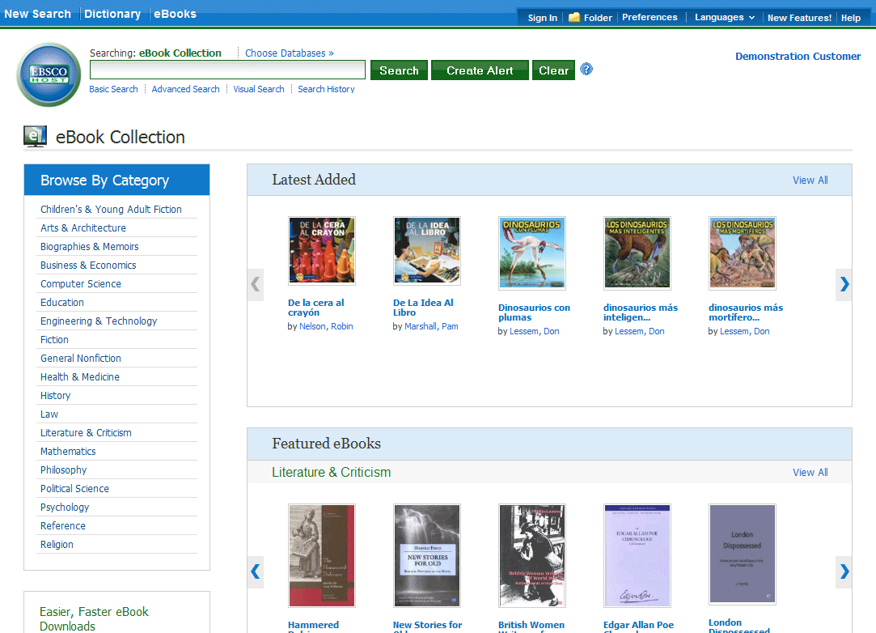
There are several ways to search for EBSCO eBooks:
- Perform a keyword search of the eBooks database using the Find field.
- Browse by Category by selecting a category from the column on the left.
- View the Latest Added eBooks using the left and right arrows or click View All to view a result list of all latest added eBooks.
- View Featured eBooks using the left and right arrows or click View All to view a result list of all Featured eBooks.

Note: If you are accessing EBSCO eBooks in EBSCO Discovery Service, the eBook Collection landing page is not available.

To search for eBooks:
- Enter your search terms in the Find field and click the Search button
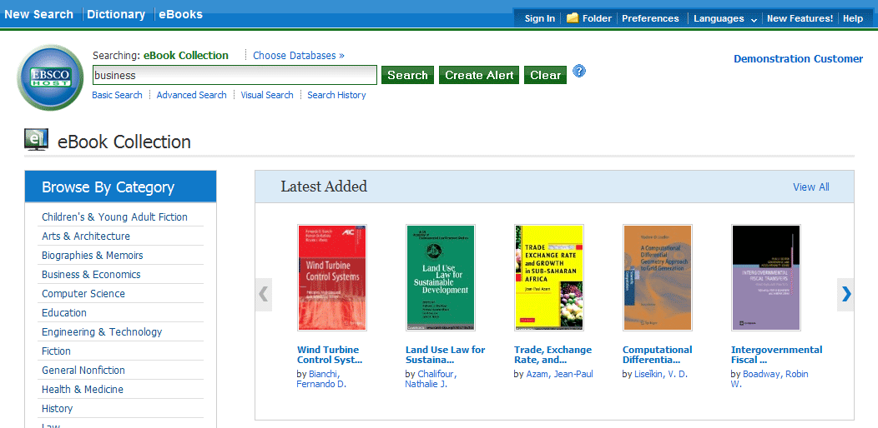
- A Result List of eBooks related to your search terms is displayed.
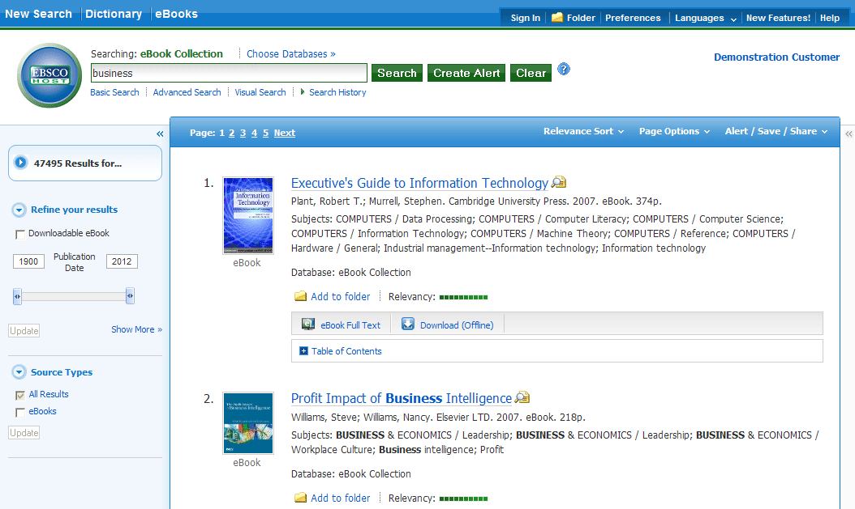

- Click the eBook Full Text link to read the book in the eBook Viewer tool.
- Click the Download (Offline) link to check out the book and read it on your computer using Adobe Digital Editions. (See Downloading an eBook below)
Note: Libraries that have eBook download capabilities enabled will see a Download (Offline) link.
- Click the Table of Contents link to view the chapters of an eBook. You can go directly to a chapter in the eBook Viewer tool by clicking on a hyperlinked chapter.
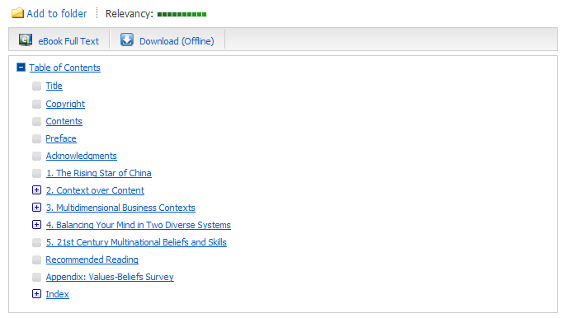
Note: Sections in the Table of Contents with a plus sign (+) can be expanded further by clicking the plus sign.

eBook Detailed Record
A Detailed Record can be viewed by clicking an eBook title in the Result list. From the Detailed Record, you can read or download the eBook using the links in the left column. From the right column, you can print, email, save, or export the record, as well as add the details about the eBook to your folder.
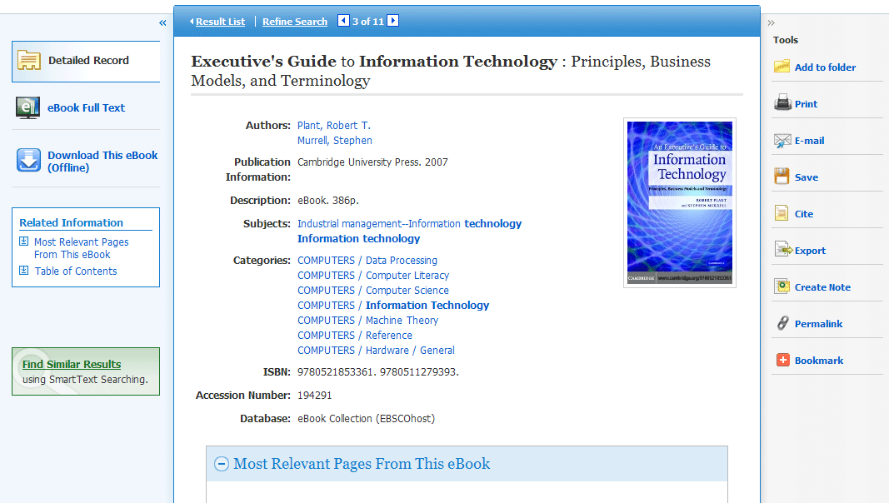
At the bottom of the Detailed Record, you can view Search Terms Within this eBook and the Table of Contents. Both sections can be collapsed or expanded by clicking the plus (+) or minus (-) in the upper left corner of the section.
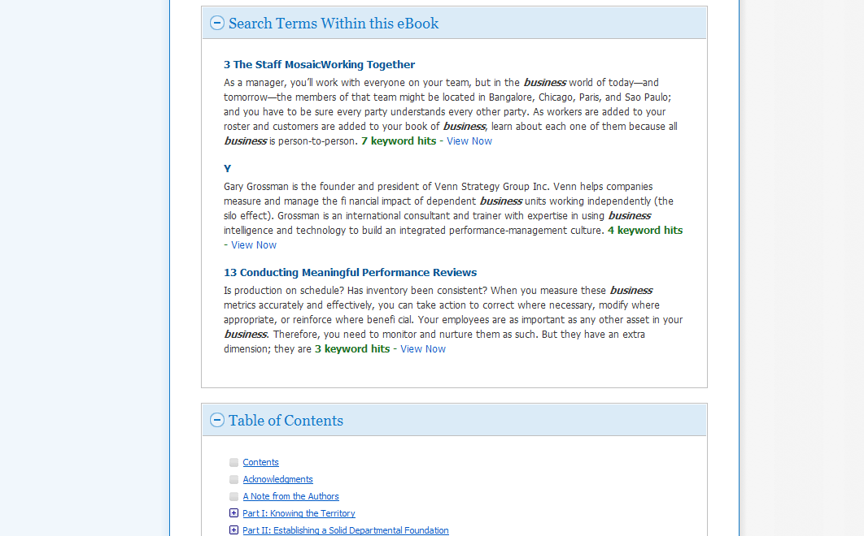
- Search Terms Within this eBook: Displays the most relevant sections of the eBook in which your search terms appear in the text.
- Table of Contents: Displays the Table of Contents for the eBook you are viewing. Clicking on a hyperlinked chapter opens the chapter in the eBook Viewer tool.

eBook Viewer
eBooks can be read online in the eBook Viewer by clicking the eBook Full Text link in the Result list or Detailed Record.
Note: If you are using a Mac, you will need to install a PDF Browser plug-in in order to use the eBook Viewer.
Click to download the Schubert|it plug-in.
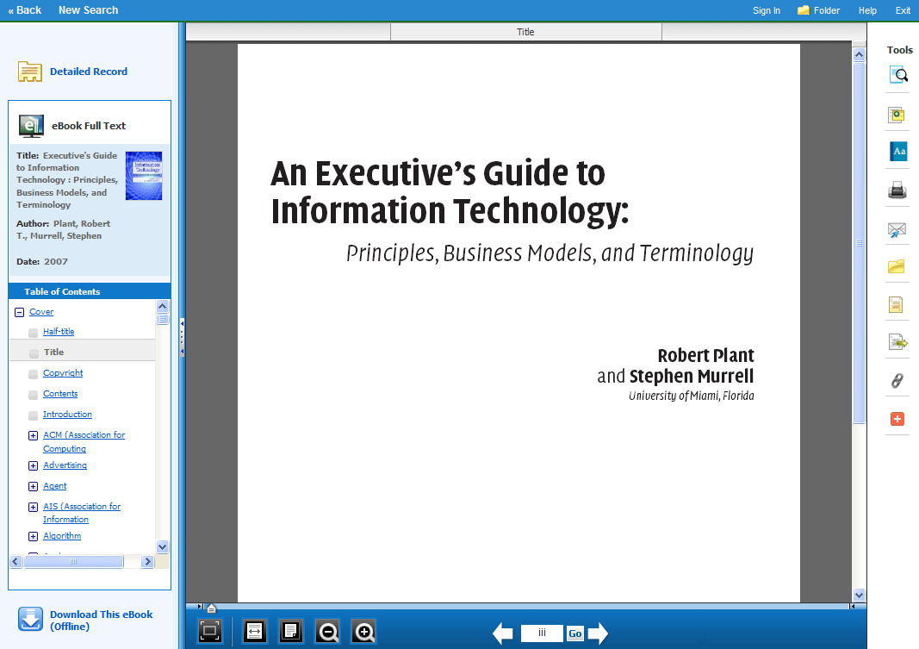
In the top toolbar of the eBook Viewer, you can click the Back, New Search, or Exit links to check in the eBook after you have finished viewing it.
Included in the Tools column on the right, are tools that allow you to search within the text of the eBook and save a note on the eBook in your My EBSCOhost folder.
- - Click the magnifying glass icon to search for terms within the eBook.
- - Click the note icon to create a note about the eBook or a page of the eBook and save it to your personal folder.
- - Click the dictionary icon to search for definitions of words in the eBook you are reading.

Using the eBook Viewer Toolbar
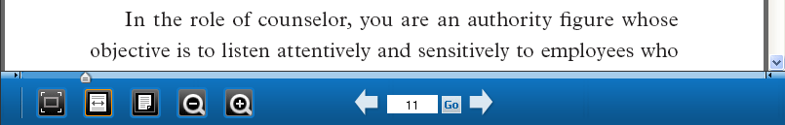
- Fit Page to Viewport: Click the icon to fit the entire page into the viewport.
- Fit Page Width: Click the icon to fit the page by width in the viewing area.
- Fit Page: Click the icon to view the entire page in the viewing area.
- Zoom Out: Click the icon to zoom out on the page.
- Zoom In: Click the icon to zoom in on the page.
- Location Slider: Drag the location slider right or left to go to a specific page of the eBook. The left and right arrows on either side of the slider bar take you to the beginning or end of the eBook. The page number updates in the Page Navigation box as you drag the location slider.
- Page Navigation: Use the page navigation arrows to move up or down one page at a time or enter a page number in the field provided and click Go.

EPUB Format
EPUB is an open eBook standard and file format that allows you to increase the size of the font, enabling you to optimize the viewing experience on desktop computers, smart phones, and tablets.
In cases when you are viewing an eBook in EPUB format, the toolbar appears as shown.
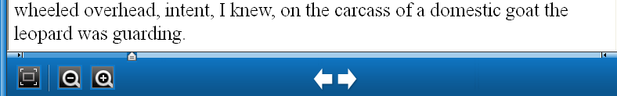
- Fit Page to Viewport: Click the icon to fit the entire page into the viewport.
- Zoom Out: Click the icon to display the text in a smaller font size.
- Zoom In: Click the icon to display text in a larger font size.
Note: EPUB format is not compatible with Internet Explorer browsers 7 & 8. When trying to open an EPUB format eBook in IE 7 or 8, you are prompted to upgrade your browser to IE 9. For more info about EPUB, click here.

Downloading an eBook
If your library offers eBook download capabilities, you may choose to download an eBook to your computer and read it offline at a later time.
Note: Adobe® Digital Editions 1.7.1 or higher is required for offline viewing. This free software can be downloaded from http://www.adobe.com/products/digitaleditions.
To download an eBook:
- Click the Download (Offline) link for the eBook you would like to download.
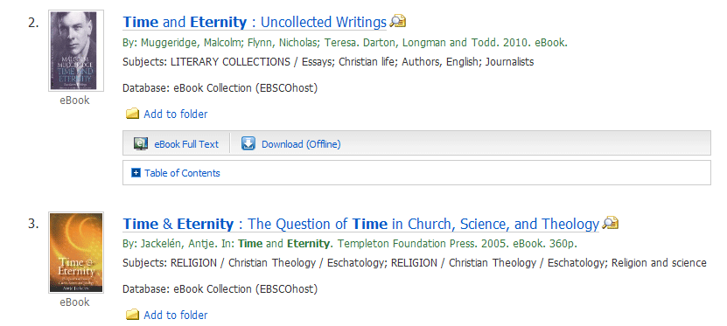
If you are not logged into your My EBSCOhost folder, you are prompted to do so.
- Select a Checkout period from the drop-down menu and click the Checkout & Download button.
Note: For some titles, you may see the option to select either the PDF or ePub format for your download. ePub is an open format that allows you to resize the text, enabling you to optimize the viewing experience on desktop computers, smart phones, and tablets.
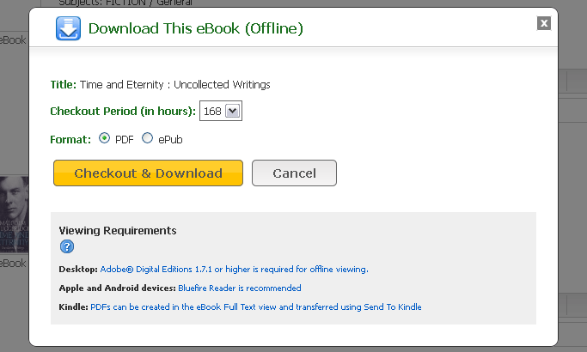
The eBook is added to the Checkout area of the folder, accessible from the upper-right corner of the EBSCOhost interface. If you are not logged into your My EBSCOhost folder, you are prompted to do so.
- Select Open with or Save File from the resulting dialog box.
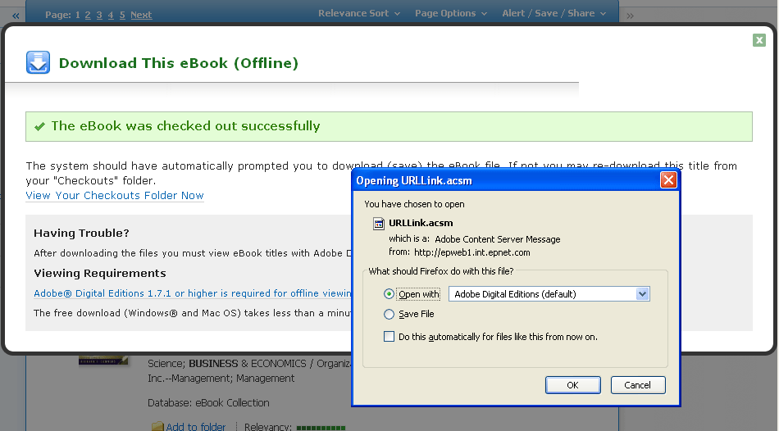
If you select Open with, your eBook is opened with Adobe® Digital Editions. If you select Save file, the eBook is saved to your computer and can be opened with Adobe® Digital Editions at a later time.
- When a downloaded eBook is opened, it is displayed in Adobe® Digital Editions.
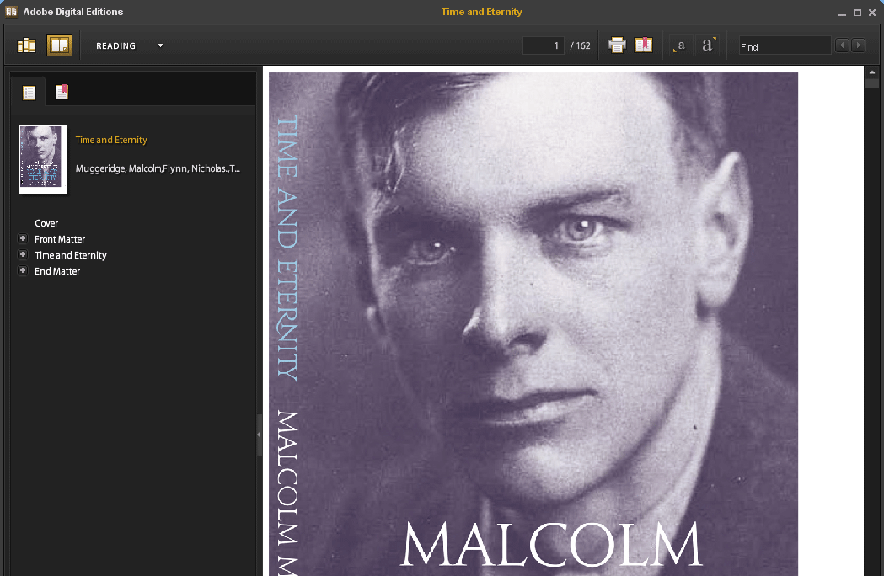

Placing a Hold on an eBook
If the eBook you have chosen to download is in use by another patron, and if your library offers Holds capabilities, you have the opportunity to place a hold on the eBook to download when it becomes available. Enter your e-mail address in the field provided and click the Place Hold button.
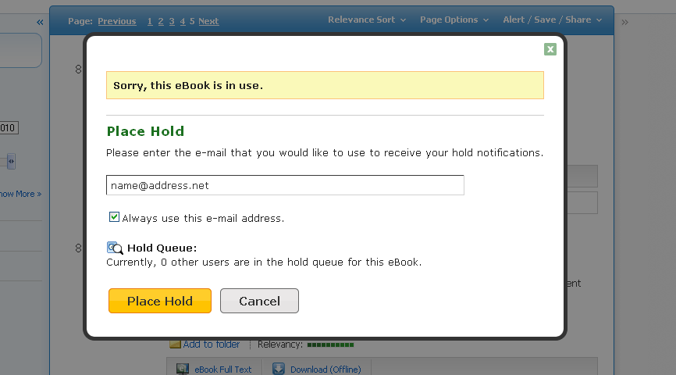
The eBook is placed in the Holds area of your My EBSCOhost Folder. When the eBook is available, you are notified via the e-mail address you provided and the eBook appears in the Checkouts area of your folder.

eBooks and the My EBSCOhost Folder
eBooks may appear in the folder in three areas.
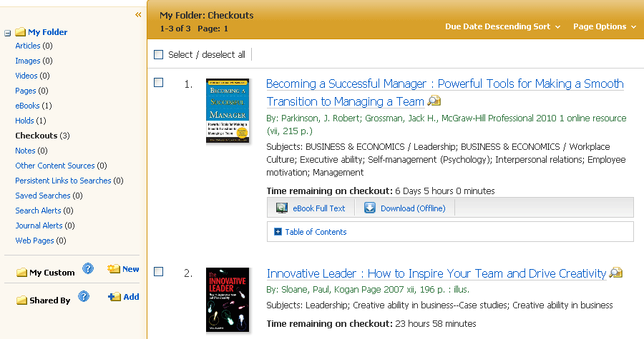
eBooks: When a user adds an eBook to their folder, information about the eBook appears in the eBooks area of the folder, without the eBook being checked out. eBooks may be added to the folder by clicking on the folder icon in the Result List or Detailed Record.
Holds: When a hold is placed on an eBook that is in use by another patron, it is added to the Holds area. Holds must be enabled by your library to place a hold on an eBook.
Checkouts: When an eBook is checked out, it is added to the Checkouts area of the folder. If you have not yet downloaded the eBook, it can be accessed and downloaded from here.

Creating Notes on eBooks
The Notetaking feature assists with your research by allowing you to take notes on eBooks and save them to your My EBSCOhost folder for later viewing.
To use the Notetaking feature in EBSCOhost:
- From the page of the eBook on which you would like to leave a note, click on the Notes icon in the toolbar.
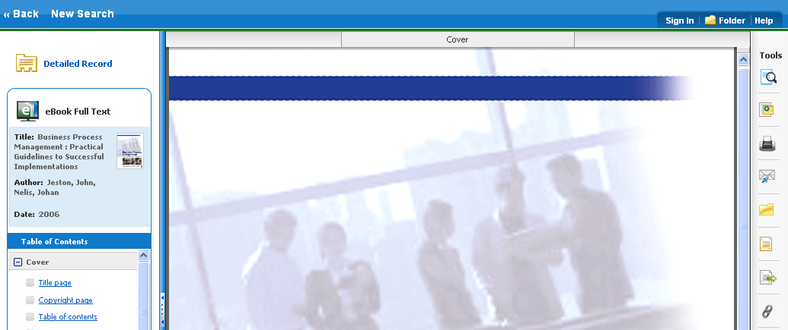
- Click the + New Note button that appears in the Notes area. If there are existing notes, they appear in a list in the Notes area.
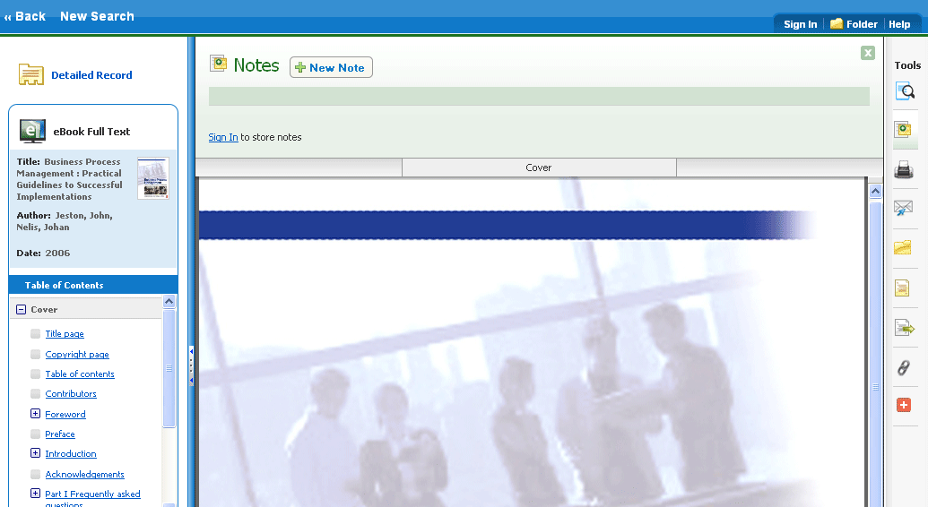
Note: Click the Sign In link to save your note to your personal My EBSCOhost folder account.

- Enter your note text in the field provided and click the Save button.
You can adjust how the text appears in your note using the Bold, Italics, and Underline buttons above the text field.
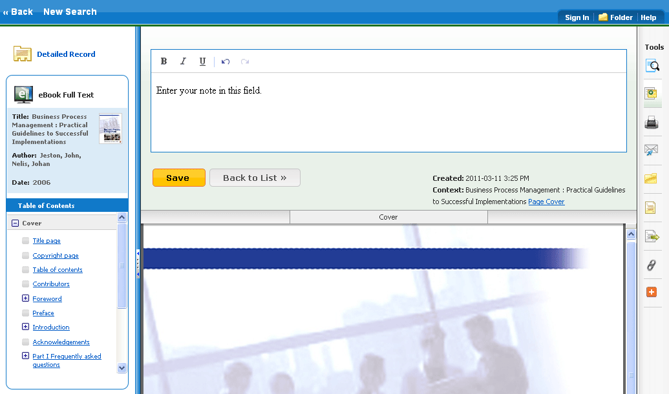
- Your saved note appears in the Notes list.
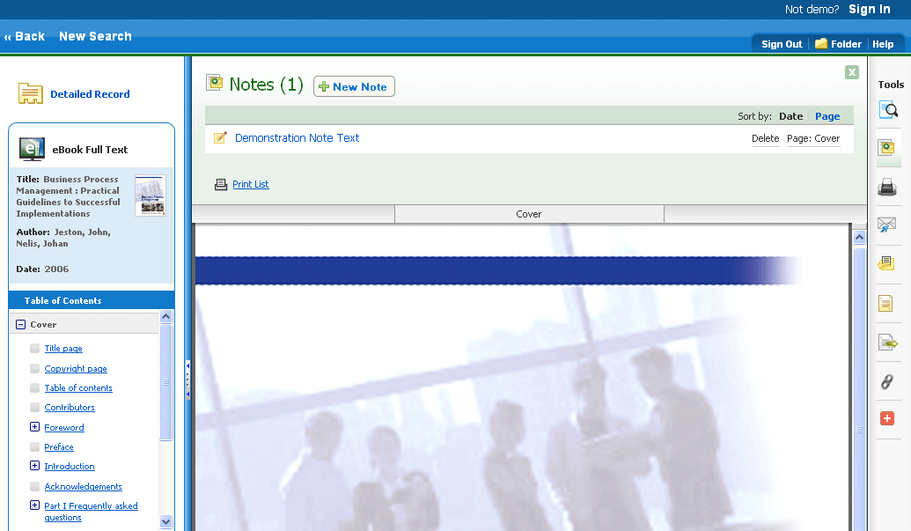
- Click the Note title to edit the text.
- Hover your pointer over the note to either Delete or view the page number of the note.
- Click the in the upper-left corner to close the Notes area.

Dictionary
You can search within Oxford American College Dictionary by clicking the Dictionary link in the top toolbar when EBSCO eBooks is being searched.
To browse the Dictionary:
- Click the Dictionary link in the top toolbar.
- Enter a word, part of a word, or first letter of a word in the Find field in the left column and click the Browse button. A list of entries is displayed.
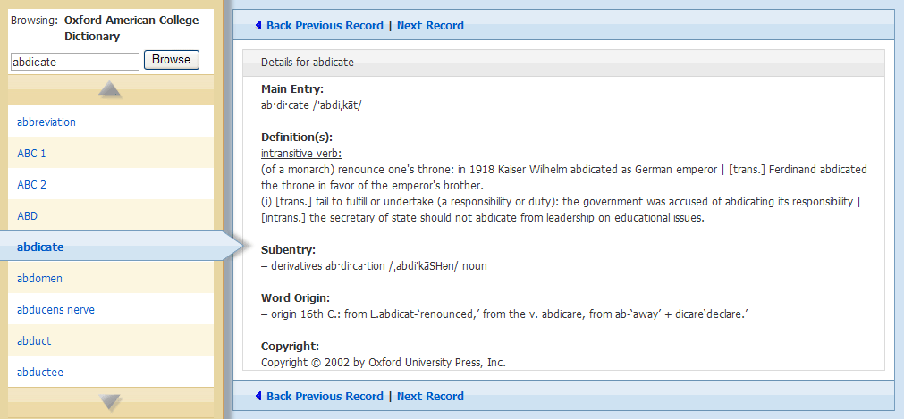
- Use the up and down arrows to browse through the Dictionary Browse List.
- To view an entry, click on the hyperlinked word.

